Practice EOC

- After a volcanic eruption has covered an area with lava, which of the following is the most likely order of succession in the repopulation of the area?
  - lichens → grasses → shrubs → trees
  - mosses → grasses → lichens → trees
  - grasses → trees → mosses → lichens
  - shrubs → grasses → trees → lichens
- The cell membrane of the red blood cell will allow water, oxygen, carbon dioxide, and glucose to pass through. Because other substances are blocked from entering, this membrane is called
  - perforated.
  - semi-permeable.
  - non-conductive.
  - permeable.
- There are many different enzymes located in the cytoplasm of a single cell. How is a specific enzyme able to catalyze a specific reaction?
  - Different enzymes are synthesized in specific areas of the cytoplasm.
  - Most enzymes can catalyze many different reactions.
  - An enzyme binds to a specific substrate (reactant) for the reaction catalyzed.
  - Enzymes are transported to specific substrates (reactants) by ribosomes.
- Some snake venoms are harmful because they contain enzymes that destroy blood cells or tissues. The damage caused by such a snakebite could best be slowed by
  - applying ice to the bite area.
  - drinking large amounts of water.
  - inducing vomiting.
  - increasing blood flow to the area.
- The plasma membrane of a cell consists of
  - protein molecules arranged in two layers with polar areas forming the outside of the membrane.
  - two layers of lipids organized with the nonpolar tails forming the interior of the membrane.
  - lipid molecules positioned between two carbohydrate layers.
  - protein molecules with polar and nonpolar tails.
- The plasma membrane of a cell consists of
  - protein molecules arranged in two layers with polar areas forming the outside of the membrane.
  - two layers of lipids organized with the nonpolar tails forming the interior of the membrane.
  - lipid molecules positioned between two carbohydrate layers.
  - protein molecules with polar and nonpolar tails.
- Which of the following best describes meiosis?
  - It is carried out in all tissues that require cell replacement.
  - It occurs only in cells in the reproductive structures of the organism.
  - It happens in all tissues except the brain and spinal cord.
  - It is the first stage of mitosis.
- Which of the following sequences represents chromosome number during fertilization? (n= number of chromosomes)
  - n + n→ 2n
  - 2n → n + n
  - n → n
  - 2n → 2n
- Based only on the sex chromosomes in typical human egg and sperm cells at fertilization, the probability of producing a female is
  - 25%.
  - 50%.
  - 75%.
  - 90%
- Black fur (B) is dominant over white fur (b) and short hair (S) is dominant over long hair (s). The following genotypes were found in a male and female cat: BbSs (male) and bbSS (female). Which of the following choices is true of the phenotype of offspring from these parents?
  - All offspring will have black fur
  - All offspring will have white fur
  - All offspring will have long hair
  - All offspring will have short hair
- If a human baby boy inherits a recessive allele from his mother, in which circumstance would he most likely show the trait coded for by the recessive allele?
  - The baby inherits the dominant allele from his father.
  - The allele is on an autosomal chromosome and the baby is a twin.
  - The allele is on the X chromosome.
  - The allele is on the Y chromosome
- ATCAGCGCTGGC
The above sequence of DNA is part of a gene. How many amino acids are coded for by this segment?
  - 4
  - 8
  - 12
  - 20
- Scientists found that, over a period of 200 years, a mountain pond was transformed into a meadow. During that time, several communities of organisms were replaced by different communities. Which of these best explains why new communities were able to replace older communities?
  - The original species became extinct.
  - Species in the older community died from old age.
  - The abiotic characteristics of the habitat changed.
  - Diseases that killed the older organisms disappeared.
- A food chain is shown below
Grasses crickets field mice hawks
For this particular food chain, which of the following changes would have the most severe consequences?
- a drastic decrease in rainfall, causing drought
- the poaching of predatory hawks by game hunters
- the introduction of a second predator that eats field mice
- a parasitic infestation that reduces the cricket population
- Complete burning of plant material returns carbon primarily to the
  - herbivores.
  - water.
  - vegetation.
  - atmosphere.

- A healthy individual is a carrier of a lethal allele but is unaffected by it. What is the probable genotype of this individual?
  - two dominant normal alleles
  - one recessive lethal allele and one dominant lethal allele
  - one recessive lethal allele and one dominant normal allele
  - one dominant lethal allele and one recessive normal allele
- A population of termites initially consists of darkly colored and brightly colored members. After several generations, the termite population consists almost entirely of darkly colored members because the brightly colored termites are easier for a predatory species of insectivores to locate. This situation is an example of
  - the evolution of a new species.
  - natural selection.
  - artificial selection.
  - adaptive radiation
- Which of these best illustrates natural selection?
  - An organism with favorable genetic variations will tend to survive and breed successfully.
  - A population monopolizes all of the resources in its habitat, forcing other species to migrate.
  - A community whose members work together utilizes all existing resources and migratory routes.
  - The largest organisms in a species receive the only breeding opportunities.
- A single species of squirrel evolved over time into two species, each on opposite sides of the Grand Canyon. This change was most likely due to
  - higher mutation rates on one side.
  - low genetic diversity in the initial population.
  - the isolation of the two groups.
  - differences in reproductive rates.
- Which of the following require a host cell because they are not able to make proteins on their own?
  - blue-green algae
  - bacteria
  - protozoans
  - viruses
- A person with swollen gums rinses his mouth with warm salt water, and the swelling decreases. Which has occurred?
  - The swollen gums have absorbed the saltwater solution.
  - The saltwater solution lowers the temperature of the water in the gums.
  - The salt in the solution has moved against the concentration gradient.
  - The water in the gums has moved from a high to a low concentration of water.
- Which set of parents can most likely produce a child with type O blood?
  - one parent with type AB blood, and the other parent with type A blood
  - one parent with type AB blood, and the other parent with type O blood
  - one parent with heterozygous type A blood, and the other parent with type O blood
  - one parent with homozygous type A blood, and the other parent with homozygous type B blood
- One of the parents of a child has phenylketonuria (PKU), which is caused by recessive alleles. The other parent does not have the PKU alleles. What is the chance that the couple will have a child with phenylketonuria?
  - 0%
  - 50%
  - 75%
  - 100%

- The crab Lybia tessellata carries a pair of sea anemones on its claws. The crab uses the sea anemone’s stinging tentacles as protection and the sea anemone obtains small food particles released by the crab as it feeds. Which type of symbiotic relationship does this best illustrate?
  - commensalism
  - mutualism
  - parasitism
  - predation
- Which is an example of osmosis?
  - potassium ions moving in and out of an animal cell
  - carbon dioxide moving into the leaf cells of a plant
  - oxygen moving into the bloodstream from the lungs
  - water moving into the root cells of a plant
- A scientist treats a cell with a chemical that destroys the ribosomes. As a result, which cell process will be stopped?
  - osmosis
  - photosynthesis
  - protein synthesis
  - respiration
- Two different species of bacteria are examined. Scientists find that Species X always produces CO2 and H O2 during cellular respiration. Species Y always produces ethyl alcohol and CO2 . Which conclusion can be made from these observations?
  - Only Species Y is aerobic.
  - Only Species Y is anaerobic.
  - Both Species X and Y are aerobic.
  - Both Species X and Y are anaerobic.
- Which types of organisms developed first due to the early environmental conditions on Earth?
  - prokaryotic and aerobic
  - prokaryotic and anaerobic
  - eukaryotic and aerobic
  - eukaryotic and anaerobic
- Which is an example of a learned behavior?
  - A bear cub practices catching salmon the way its mother does.
  - A baby gazelle rises to its feet within a few minutes of its birth.
  - A baby kangaroo climbs into its mother’s pouch as soon as it is born.
  - An adult salmon returns to its freshwater stream when it is time to reproduce.
- In an ecosystem, which is the most likely reason for an increase in the producer population if there is an increase in the carnivore population?
  - fewer herbivores
  - higher temperatures
  - less food
  - more oxygen
- A sugar, a phosphate group, and a nitrogen base form the building blocks of which organic compound?
  - carbohydrates
  - lipids
  - nucleic acids
  - protein

- What will most likely happen if an appropriate enzyme is added to a chemical reaction?
  - The reaction rate will increase.
  - The equilibrium of the reaction will be maintained.
  - The reaction rate will decrease.
  - The reaction will stop
- In humans, glucose is kept in balance in the bloodstream by insulin. Which concept does this best illustrate?
  - Adaptation
  - Homeostasis
  - Metabolism
  - Organization
- According to fossil records, the horses that lived 50 million years ago were much smaller, weaker, and slower than modern horses. Which process is most likely responsible for the changes that have led to the increased size, strength, and speed in horses?
  - commensalism
  - inbreeding
  - migration
  - natural selection
- A cloned plant has a diploid chromosome number of 12. What is the diploid chromosome number of the plant cell that was used to produce the cloned plant?
  - 6
  - 12
  - 18
  - 24
- When worker bees return to the hive, they perform a sequence of movements called a waggle dance to show other members of the colony where food is located. Which type of behavior does this best illustrate?
  - aggressive behavior
  - courtship behavior
  - social behavior
  - territorial behavior
- Which genetic abnormality can be identified through karyotyping?
  - point mutation
  - recessive allele
  - extra chromosome
  - sex-linked allele
- Some birds live in close association with horses. These birds feed on insects that are parasites to horses. Which type of relationship between the horses and these birds does this illustrate?
  - commensalism
  - mutualism
  - parasitism
  - predation
- Before mitosis begins, which happens before the nucleus starts dividing?
  - The cytoplasm separates.
  - The DNA replicates.
  - The sister chromatids separate.
  - The homologous chromosomes cross over.

- A sea turtle has washed up on a remote section of a beach. This is known as a “stranding.” Stranding occurs when a dead, sick or injured sea turtle washes up on the shoreline. Which statement best explains why “stranding” should be reported immediately to local authorities?
  - The information can be very useful to biologists and managers who are trying to protect the species.
  - The information can be very useful to protect sea turtles from predators.
  - The information can be very useful to local fishermen who try to catch fish that sea turtles eat.
  - The information can be very useful to tourists who may want to keep sea turtles as pets
- A strand of DNA has these bases: AGC CAT GTA TAC What is the complementary DNA strand?
  - ACG GAT CTA TAG
  - TCG GTA CAT ATG
  - TGC CTA GAT ATC
  - UCG CUA CAU AUG
- All producers and consumers use the chemical process of respiration to synthesize
  - Glucose
  - ATP
  - Alcohol
  - Oxygen
- A student measured some abiotic factors present in an aquarium in a biology laboratory. Which data did the student most likely record?
  - The weight and color of each scavenger
  - The number of each type of green plant and each type of snail
  - The size and number of each species of fish
  - The temperature and oxygen content of the water
- The bones in the wing of a bird, the flipper of a whale, and the arm of the human are all examples of
  - Heterotrophic aggregates
  - Abiotic factors
  - Complex organelles
  - Homologous structures
- Hemoglobin, insulin, albumin and maltase, which are composed of chains of amino acids, are examples of
  - Proteins
  - Carbohydrates
  - Lipids
  - Nucleic acids
- A photograph of human chromosomes that may be studied to determine possible genetic disorders is known as
  - A karyotype
  - Amniocentesis
  - Screening
  - A pedigree
- A metabolic waste of algae that can be recycled for use in cellular respiration is
  - sodium
  - carbon dioxide
  - organic acid
  - oxygen
- By which process is the potential energy of organic molecules transferred to a form of energy that is usable by the cells?
  - Digestion
  - Hydrolysis
  - Photosynthesis
  - Respiration
- In a human, what is the ratio of the normal chromosome number in a nucleus produced by mitosis to the normal chromosome number in a nucleus produced by meiosis?
  - 1:1
  - 3:1
  - 2:1
  - 4:1
- Use the dichotomous key below to identify leaf VII
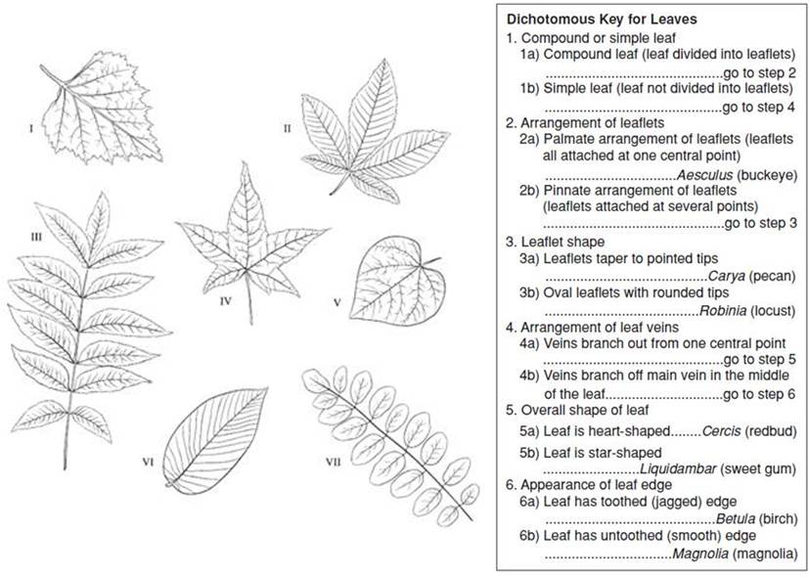

  - Aesculus
  - Carya
  - Betula
  - Robinia

