(Biology_EOC_review)
- Macromolecules
- Carbohydrates (pg 45-46)
- What elements make up carbohydrates?

- Circle the letter of each sentence that is true of carbohydrates
  - Starches and sugars are examples of carbohydrates
  - Living things use them as their main source of energy
  - The monomers in sugar polymers are starch molecules
  - Plants and some animals use them for strength and rigidity
- Single sugar molecules are also called _____________________. (these are the monomers of carbohydrates)
- What are polysaccharides?

- How do plants and animals store excess sugar?

- Lipids (pg 46-47)
- What elements make up lipids?

- Lipids are composed of a _______________ head and _____________ ____________ tails.
- Circle the letter of each way that fats are used in living things
  - As part of biological membranes
  - To store energy
  - To give plants rigidity
  - As chemical messengers
- Nucleic Acids (pg 47)
- What elements make up nucleic acids?

- The momomers that make up nucleic acids are known as __________________

- A nucleotide consists of what three parts?

- What is the function of nucleic acids in living things?

- Name two kinds of nucleic acids: ________ and _________

- Proteins (pg 47-48)
- What elements make up proteins?

- Proteins are polymers of molecules called ________________.

- What are four roles that proteins play in living things?

- Enzymes (pg 49-53)
- Complete the table about chemicals in a chemical reaction
Definition
Reactants
Products
- The energy needed to get a reaction started is called the _________________ energy
- What is a catalyst?

- Proteins that act as biological catalysts are called ______________
- What do enzymes do?
- The reactants of enzyme-catalyzed reactions are known as ______________
- Why are the active site and the substrates in an enzyme-catalyzed reaction often compared to a lock and key?

- What two things can affect enzyme potential?

- True or False: enzymes are reusable.

- Cells
- Prokaryotes and eukaryotes (pg 172-173)
- Circle the letter of each sentence that is true about prokaryotes
  - They grow reproduce
  - Many are large, multicellular organisms
  - They are more complex than cells of eukaryotes
  - They have cells membranes and cytoplasm
- Are all eukaryotes large, multicellular organisms?

- Complete the table below
Category | Definition | Examples
 | Organisms whose cells lack nuclei
 | Organisms whose cells contain nuclei

- Eukaryotic cell structure (pg 174-181)
- What is an organelle?

- Label the images below
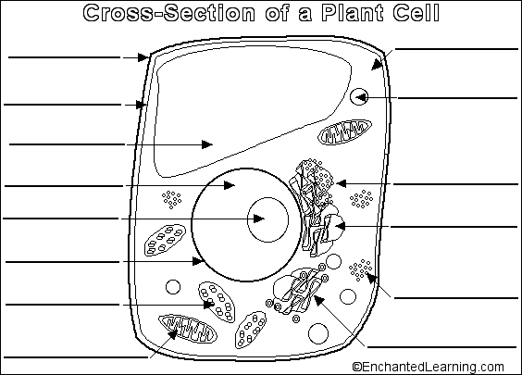

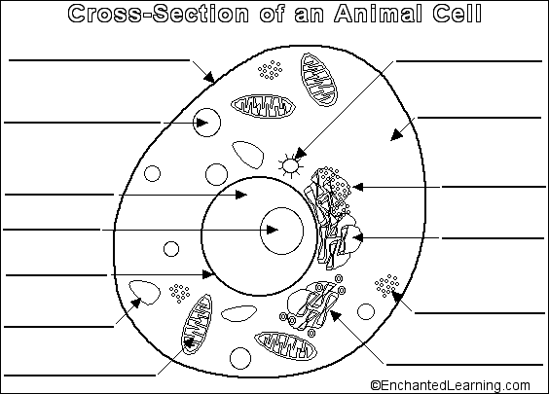

- Circle the letter of each structure that animal cells contain
  - Chloroplasts
  - Lysosomes
  - Mitochondria
  - ER
- Circle the letter of each structure that plant cells contain
  - Cell wall
  - ER
  - Lysosomes
  - Chloroplast
- Describe the function of each of the following organelles
  - Nucleus:
  - Ribosomes:
  - Vacuoles:
  - Mitochondria:
  - Chloroplasts:
  - Cell membrane:
  - Cell wall:

- Cell Boundaries (pg 182-189)
- What are the functions of the cell membrane?

- The core of nearly all cell membranes is a double-layered sheet called a(n) ___________________ _______________________
- What is the main function of the cell wall?

- What are plant cell walls mostly made of?

- What is diffusion?

- What is meant when a system has “reached equilibrium”?

- What is osmosis?

- What happens during the process of facilitated diffusion?

- What is the role of protein channels in the cell membrane?

- The energy-requiring process that moves material across a cell membrane against the concentration difference is called ____________________ __________________

- Photosynthesis and Respiration
- Photosynthesis (pg 204-207)
- What occurs in the process of photosynthesis?

- Write the overall equation for photosynthesis using words.

- Write the overall equation for photosynthesis using chemical formulas.

- Plants gather the sun’s energy with light-absorbing molecules called ___________________.

- What is the principal pigment in plants?

- Circle the letters of the regions of the visible spectrum in which chlorophyll absorbs light very well.

  - Blue-violet
  - Green
  - Red
  - Yellow
- In what organelle does photosynthesis take place?
- List 3 factors that could affect rates of photosynthesis.

- Cellular respiration (pg 221-225)
- What is cellular respiration?

- Write the equation for aerobic cellular respiration using words.

- Write the equation for aerobic cellular respiration using chemical formulas.

- How much ATP is gained during aerobic respiration? (net gain)

- What is fermentation?

- Because fermentation does not require oxygen, it is said to be __________________.

- What are the two types of fermentation?

  - ____________________
  - ____________________
- What organisms use alcoholic fermentation?

- What organisms use lactic acid fermentation?

- How much ATP is gained during fermentation? (net gain)

- DNA, RNA and Protein Synthesis
- DNA (pg 287-294)
- What is the makeup of a nucleotide?
- The four bases found in DNA are _____________________, _______________, _____________________, ___________________.
- What forms the backbone of a DNA chain?
- According to Chargaff’s rules, the percentages of _________________ are equal to those of thymine and the percentages of _____________________ are equal to those of guanine in a DNA molecule.
- The DNA molecule is shaped like a(n) ______________________ and contains ___ strands.
- Complete the flow chart below to describe the process of DNA replication.
The DNA molecule ________________, or unzips into 2 strands

Two new ______________ strands are produced using the rules of __________________.
Each strand serves as a(n)__________________, or model, to produce two new strands.

- What is the complementary strand of bases for a strand with the bases TACGTT?
- True or False: Each DNA molecule resulting from replication has one original strand and one new strand.
- RNA (pg 300-306)
- List three main differences between RNA and DNA

- What is the importance of the cell’s ability to copy a single DNA sequence into RNA?
- What is the complementary strand of mRNA bases for a DNA strand with the bases TACGTT?

- Complete the table below about the types of RNA
Type | Function
 | Carries copies of the instructions for assembling amino acids from DNA to the rest of the cell.
Ribosomal RNA

 | Transfers each amino acid to the ribosome to help assemble proteins.
- Protein synthesis (pg 300-306)
- What occurs during transcription?
- Where does transcription occur?
- What is a codon?
- What occurs during the process of translation?
- Where does translation take place?
- What is an anticodon?
- Using the chart below, determine the sequence of amino acids coded for by the following strand of DNA: ACT TTG CGA ATG

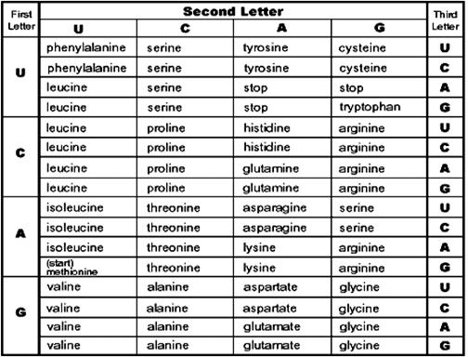

- Cell division
A. The Cell Cycle (pg 245)
1. The period of growth in between cell divisions is called __________________.
2. What is the cell cycle?

3. Interphase is divided into what three phases?

4. What happens during the G1 phase?

5. What happens during the S phase?

6. What happens during the G2 phase?
- Mitosis (pg 246-248)
- What are the four stages of mitosis?

- Name the phase described below.
  - The chromosomes move until they form two groups near the poles of the spindle
  - The chromosomes become visible. The centrioles take up positions on opposite sides of the nucleus.
  - A nuclear envelope re-forms around each cluster of chromosomes. The nucleolus becomes visible in each daughter nucleus.
  - The chromosomes line up across the center of the cell.
- What is the ending product of mitosis?
- Meiosis
- What does it mean when two sets of chromosomes are homologous?

- Define diploid.

- Define haploid.

- Why is meiosis described as a process of reduction division?

- What are the two distinct divisions of meiosis?

- How does a tetrad form in prophase I of meiosis?

- What results from the process of crossing-over during prophase I?

- What is nondisjunction? List two disorders that arise from this.

- Genetics
- Genes and Dominance (pg 264-265)
- Define the following terms.

  - Genes:

  - Hybrids:

  - Traits:

  - Alleles:

- State the principle of dominance.

- True or false: an organism with a recessive allele for a particular form of a trait will always exhibit that form.

- Probability and Punnett Squares (pg 267-269)
- How to geneticists use Punnett squares?
- Complete the Punnett square below.
Parents: Tt X Tt
 | T | t
T
t
- Define the following terms
  - Genotype:

  - Homozygous:

  - Phenotype:

  - Heterozygous:

***Make sure you know HOW to do Punnett squares!!!****
- Complete the table of the different patterns of inheritance.
Type | Description | Examples
 | One allele is not completely dominant over another. The heterozygous phenotype is somewhere between the two homozygous phenotypes.
 | Both alleles contribute to the phenotype of the organism.
 | Genes have more than two alleles.
 | Two or more genes control a trait.

- Blood Types
8. Fill in the blood type chart below.
Blood Type | Genotype | Can receive blood from
A
B
AB
O

9. Could a child with type B blood have parents with type A and B blood? Draw a Punnett square to support the answer.

- Human Genetics and Disease (pg 341-353)
10. What is a karyotype?

11. What can be seen using a karyotype?

12. What does a pedigree show?

13. What does a circle represent in a pedigree? A Square?

14. Fill in the genotype for each person in the pedigree below.
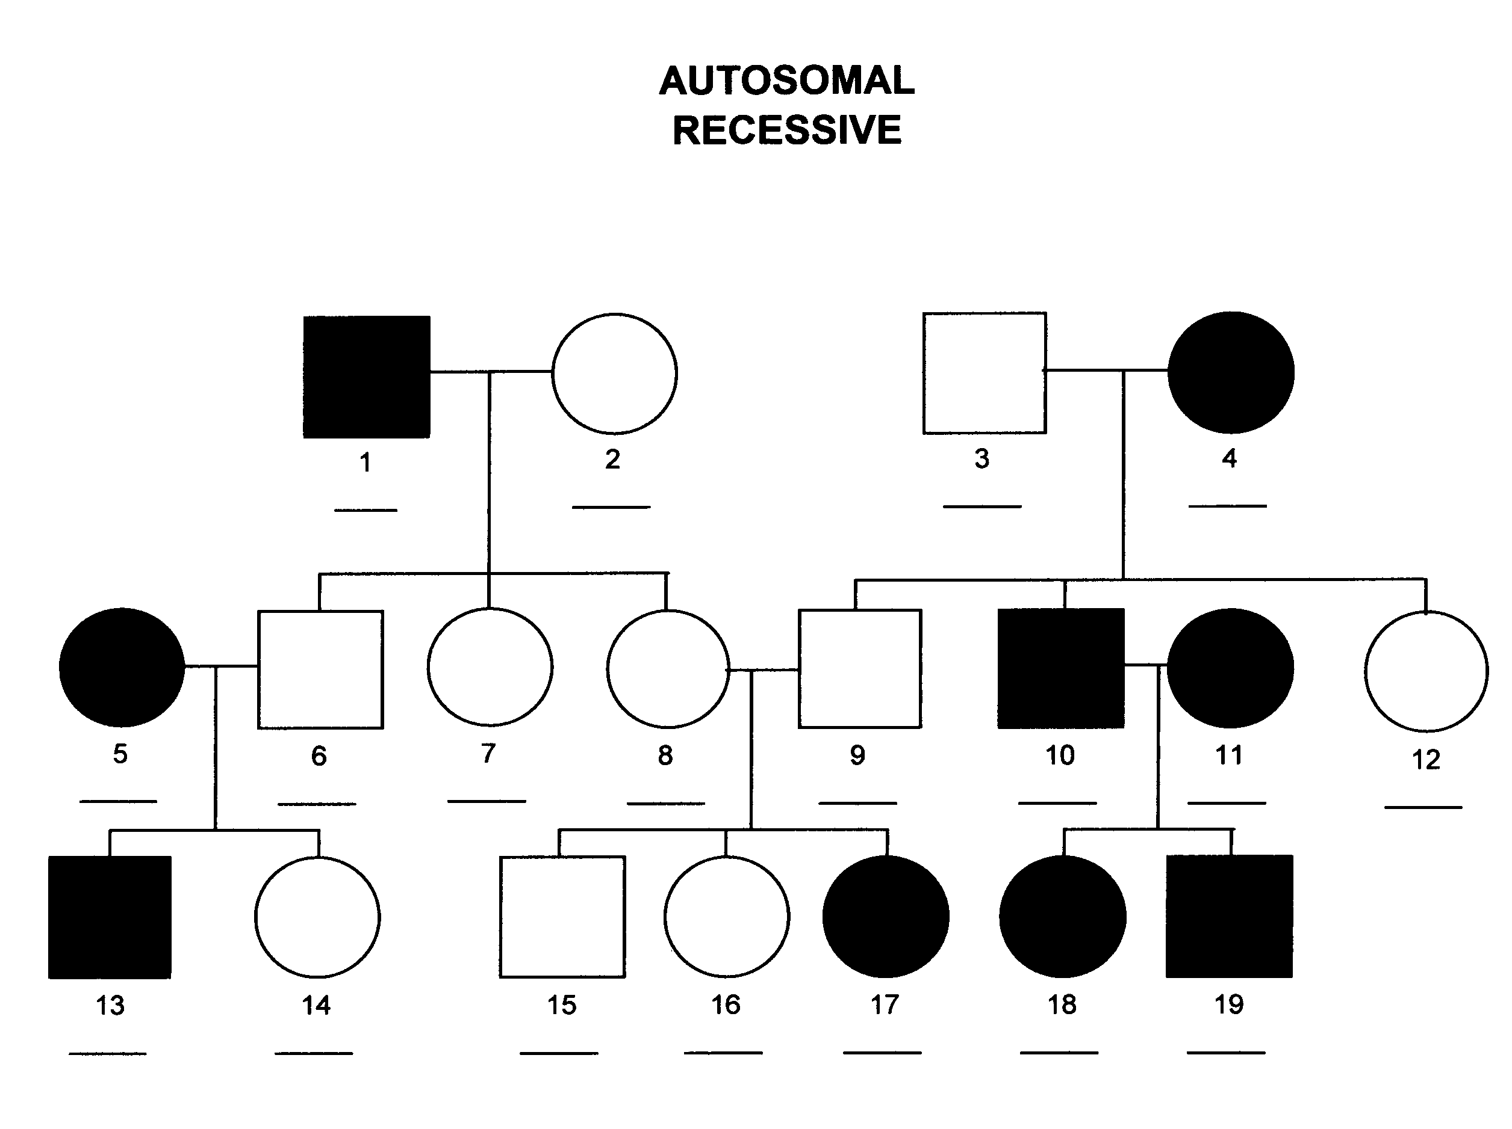

15. What is huntington’s disease?
16. What is sickle cell anemia?
17. How is sickle cell linked to malaria resistance?
18. What is cystic fibrosis?
19. What are sex linked genes?
20. List 4 disorders that are linked to the X chromosome.
21. Why do men show sex linked disorders more often than women?
22. Complete the Punnett square to show how colorblindness is inherited. (remember, colorblindness is recessive)
 | X^{c} | Y
X^{C}
X^{c}

- Biotechnology
A. Cellular Transformation (pg 327-329)
1. What occurs during transformation?
2. Complete the flow chart to show the steps in transforming bacteria.
_____________ enzymes are used to cut both the bacterial plasmid and the desired DNA from the donor.
A ___________________, or circular DNA molecule, is removed from a bacteria.

The modified plasmid is inserted back into the bacteria and the bacteria begins making new __________________.
The DNA from the donor species is inserted into the bacterial plasmid forming _________________ DNA

- Transgenic organisms (pg 331-333)

- Why would a scientist want to create transgenic
organisms?

